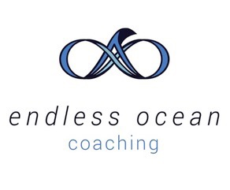
Client Information and Questionnaire
Coach Shannon Kelly with Endless Ocean Coaching

Name:
Phone number:
Email Address:
Current Employment:
Position:
Personality:
https://www.16personalities.com/free-personality-test

Questions

What three specific outcomes or results would you like to achieve in coaching process?

What are 3 of the biggest changes you want to make to your life in the next 3 years?

What would you say are the three biggest accomplishments of your life?

What do you think your special talents, gifts and strengths are?

What are your primary stressors in life?

How do you want to feel after the coaching process?

How can I support you in the coaching process?

What brings you joy? (can be big or small – All are valid!)

